Ideation Phase
Brainstorm & Idea Prioritization Template
Date | 14 October 2026
Team ID
Project Name | Automated Network Request Management System
Maximum Marks | 4 Marks

Brainstorm & Idea Prioritization Template:
Brainstorming provides a free and open environment that encourages everyone within a team to participate in the creative thinking process that leads to problem solving. Prioritizing volume over value, out-of-the-box ideas are welcome and built upon, and all participants are encouraged to collaborate, helping each other develop a rich amount of creative solutions.
Use this template in your own brainstorming sessions so your team can unleash their imagination and start shaping concepts even if you're not sitting in the same room.
Reference: https://www.mural.co/templates/brainstorm-and-idea-prioritization
Step-1: Team Gathering, Collaboration and Select the Problem Statement
The project team collaborated to address manual enterprise network provisioning delays, missing specifications, and lack of fulfillment tracking. The chosen focus is automating the end-to-end lifecycle on ServiceNow.
Step-2: Brainstorm, Idea Listing and Grouping
Ideas were grouped into four technical clusters as shown below:
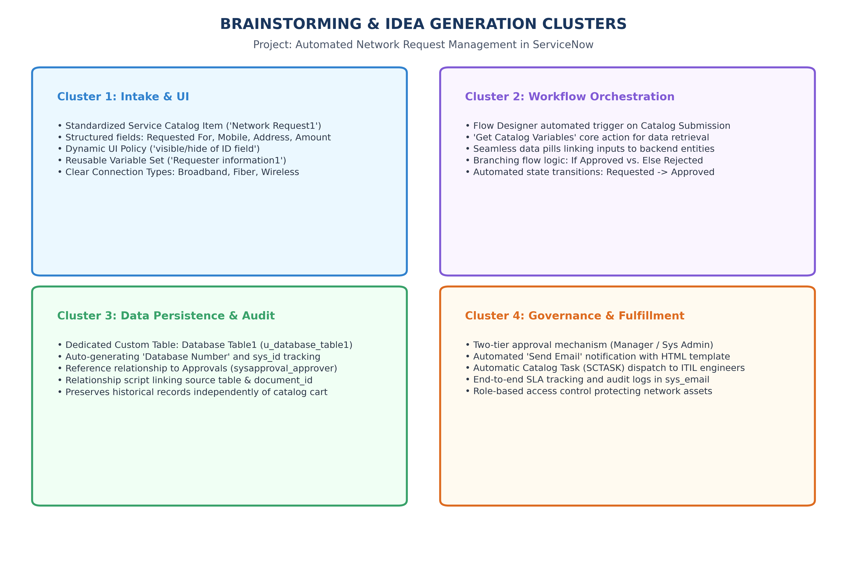
Figure 1.1: Brainstorming Thematic Clusters for ServiceNow Network Request Workflow
Cluster Breakdown:
1. Intake & UI: Standardized Service Catalog item ('Network Request1'), 7 variables, Catalog UI Policy ('visible/hide of ID field').
2. Workflow Orchestration: Flow Designer automated trigger, 'Get Catalog Variables', data pills, and approval branching.
3. Data Persistence & Audit: Dedicated custom table Database Table1 (u_database_table1) with auto-numbering and sys_relationship.
4. Governance & Fulfillment: Automated manager approvals, email alerts via sys_email, and Catalog Task (sc_task) dispatch.
Step-3: Idea Prioritization
Ideas were prioritized using an Impact vs. Effort 2x2 matrix:
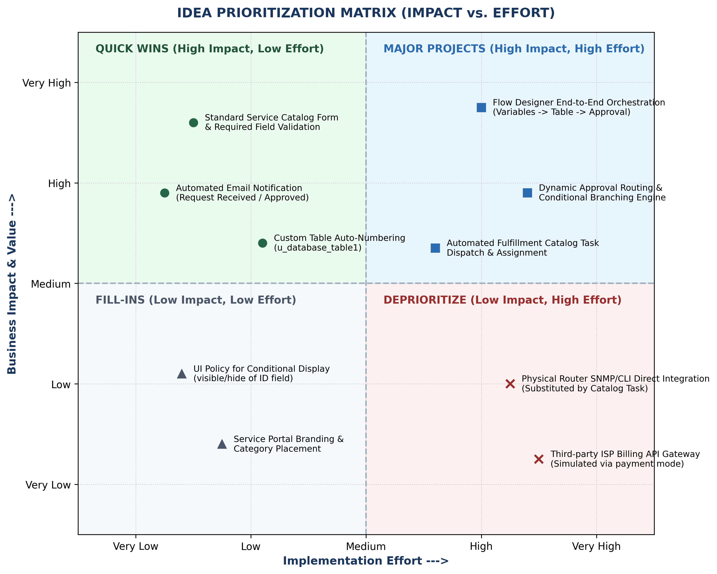
Figure 1.2: Idea Prioritization Matrix (Impact vs. Effort)

